**Practical 3**

**Aim: Programs related to different LayoutsCoordinate, Linear, Relative, Table, Absolute, Frame, List View, Grid View.**

**Step 1:** Create a new project in Kotlin and select Empty Views Activity template.

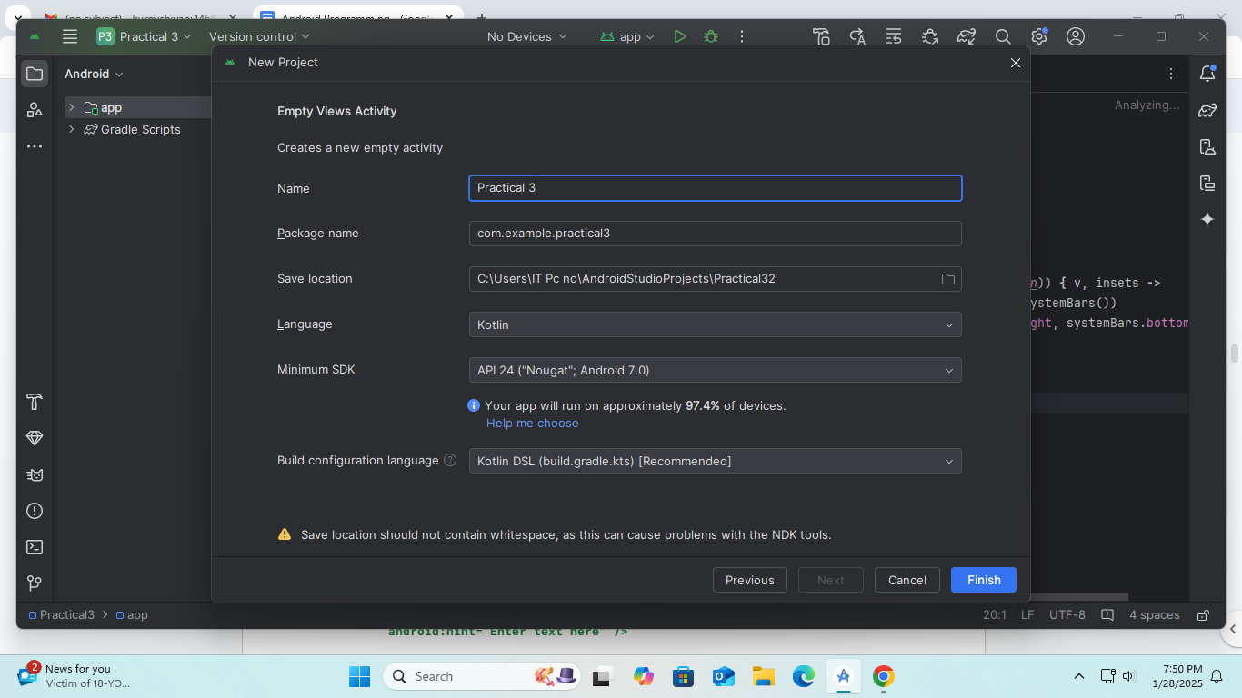

**Step 2:** activity_main.xml

<ScrollView xmlns:android="http://schemas.android.com/apk/res/android"

    android:layout_width="match_parent"

    android:layout_height="match_parent"

    android:padding="16dp">

    <LinearLayout

        android:layout_width="match_parent"

        android:layout_height="wrap_content"

        android:orientation="vertical">

        <Button

            android:id="@+id/btnCoordinate"

            android:layout_width="match_parent"

            android:layout_height="wrap_content"

            android:text="Coordinate Layout" />

        <Button

            android:id="@+id/btnLinear"

            android:layout_width="match_parent"

            android:layout_height="wrap_content"

            android:text="Linear Layout" />

        <Button

            android:id="@+id/btnRelative"

            android:layout_width="match_parent"

            android:layout_height="wrap_content"

            android:text="Relative Layout" />

        <Button

            android:id="@+id/btnTable"

            android:layout_width="match_parent"

            android:layout_height="wrap_content"

            android:text="Table Layout" />

        <Button

            android:id="@+id/btnAbsolute"

            android:layout_width="match_parent"

            android:layout_height="wrap_content"

            android:text="Absolute Layout" />

        <Button

            android:id="@+id/btnFrame"

            android:layout_width="match_parent"

            android:layout_height="wrap_content"

            android:text="Frame Layout" />

        <Button

            android:id="@+id/btnListView"

            android:layout_width="match_parent"

            android:layout_height="wrap_content"

            android:text="List View" />

        <Button

            android:id="@+id/btnGridView"

            android:layout_width="match_parent"

            android:layout_height="wrap_content"

            android:text="Grid View" />

    </LinearLayout>

</ScrollView>

**Step 3:** MainActivity.kt

package com.example.layoutexamples

import android.content.Intent

import androidx.appcompat.app.AppCompatActivity

import android.os.Bundle

import kotlinx.android.synthetic.main.activity_main.*

class MainActivity : AppCompatActivity() {

    override fun onCreate(savedInstanceState: Bundle?) {

        super.onCreate(savedInstanceState)

        setContentView(R.layout.activity_main)

val btnCoordinate = findViewById<Button>(R.id.btnCoordinate)

val btnLinear = findViewById<Button>(R.id.btnLinear)

val btnRelative = findViewById<Button>(R.id.btnRelative)

val btnTable = findViewById<Button>(R.id.btnTable)

val btnAbsolute = findViewById<Button>(R.id.btnAbsolute)

val btnFrame = findViewById<Button>(R.id.btnFrame)

val btnListView = findViewById<Button>(R.id.btnListView)

val btnGridView = findViewById<Button>(R.id.btnGridView)

        // Setting up listeners for each button

        btnCoordinate.setOnClickListener {

            startActivity(Intent(this, CoordinateActivity::class.java))

        }

        btnLinear.setOnClickListener {

            startActivity(Intent(this, LinearActivity::class.java))

        }

        btnRelative.setOnClickListener {

            startActivity(Intent(this, RelativeActivity::class.java))

        }

        btnTable.setOnClickListener {

            startActivity(Intent(this, TableActivity::class.java))

        }

        btnAbsolute.setOnClickListener {

            startActivity(Intent(this, AbsoluteActivity::class.java))

        }

        btnFrame.setOnClickListener {

            startActivity(Intent(this, FrameActivity::class.java))

        }

        btnListView.setOnClickListener {

            startActivity(Intent(this, ListViewActivity::class.java))

        }

        btnGridView.setOnClickListener {

            startActivity(Intent(this, GridViewActivity::class.java))

        }

    }

}

**Step 4:** Create a new activity – CoodinateActivity.kt

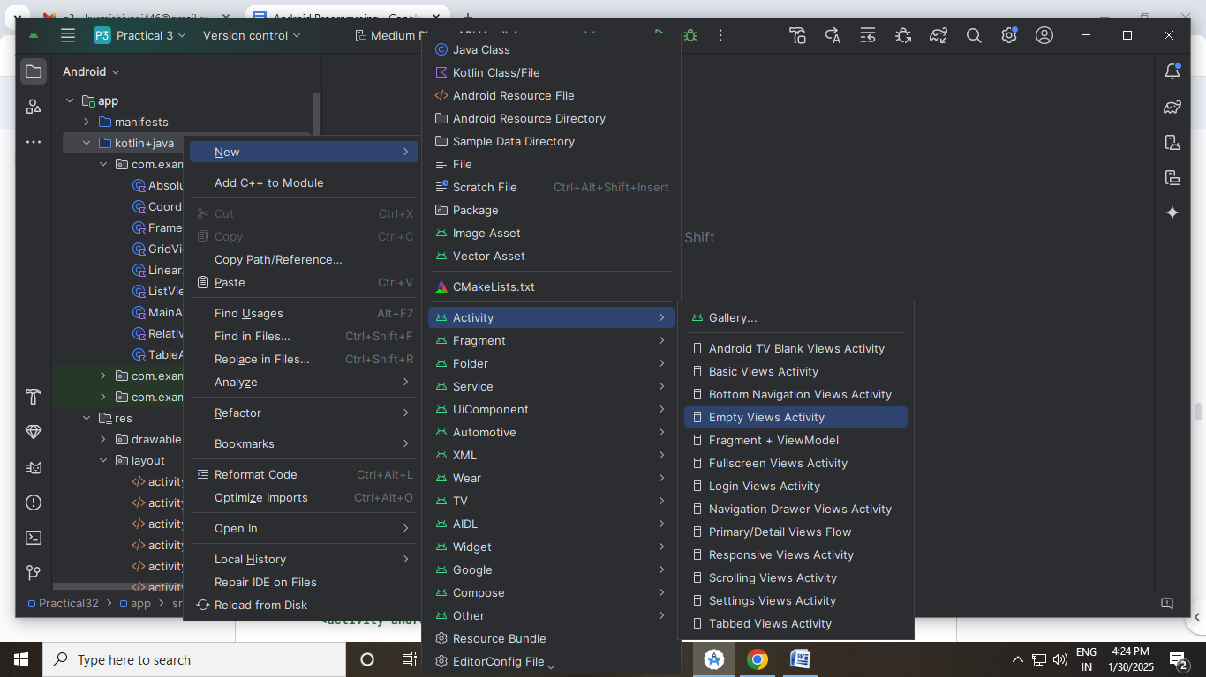

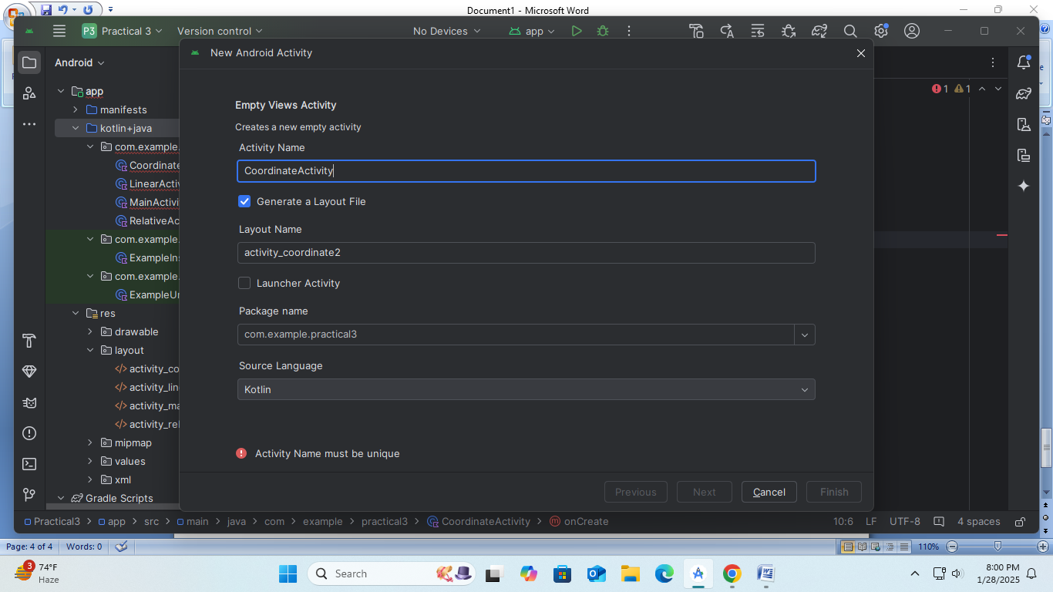

package com.example.layoutexamples

import android.os.Bundle

import androidx.appcompat.app.AppCompatActivity

class CoordinateActivity : AppCompatActivity() {

    override fun onCreate(savedInstanceState: Bundle?) {

        super.onCreate(savedInstanceState)

        setContentView(R.layout.activity_coordinate)

    }

}

**Step 5:** activity_coordinate.xml

<androidx.coordinatorlayout.widget.CoordinatorLayout

    xmlns:android="http://schemas.android.com/apk/res/android"

    android:layout_width="match_parent"

    android:layout_height="match_parent">

    <!-- Example of a FAB -->

    <com.google.android.material.floatingactionbutton.FloatingActionButton

        android:layout_width="wrap_content"

        android:layout_height="wrap_content"

        android:layout_gravity="bottom|end"

        android:layout_margin="16dp"

        android:contentDescription="Floating Action Button"

        android:src="@android:drawable/ic_menu_add" />

</androidx.coordinatorlayout.widget.CoordinatorLayout>

**Step 6:** Create a new activity – LinearActivity.kt

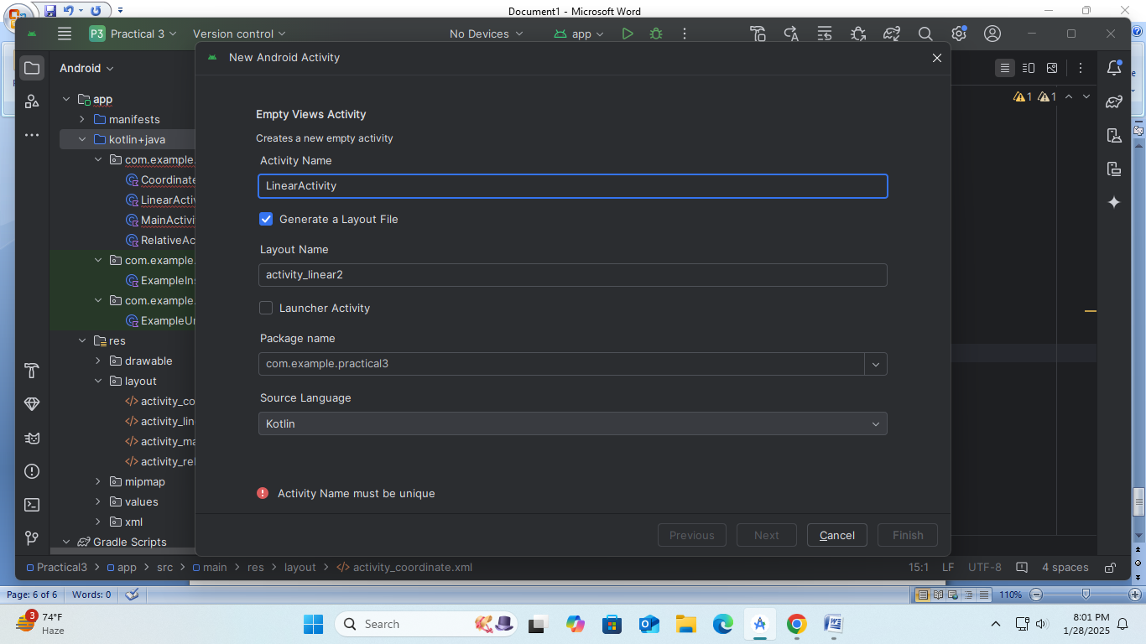

package com.example.layoutexamples

import android.os.Bundle

import androidx.appcompat.app.AppCompatActivity

class LinearActivity : AppCompatActivity() {

    override fun onCreate(savedInstanceState: Bundle?) {

        super.onCreate(savedInstanceState)

        setContentView(R.layout.activity_linear)

    }

}

**Step 7:** activity_linear.xml

<LinearLayout xmlns:android="http://schemas.android.com/apk/res/android"

    android:layout_width="match_parent"

    android:layout_height="match_parent"

    android:orientation="vertical"

    android:padding="16dp">

    <TextView

        android:layout_width="match_parent"

        android:layout_height="wrap_content"

        android:text="This is a TextView in LinearLayout" />

    <EditText

        android:layout_width="match_parent"

        android:layout_height="wrap_content"

        android:hint="Enter text here" />

    <Button

        android:layout_width="wrap_content"

        android:layout_height="wrap_content"

        android:text="Submit" />

</LinearLayout>

**Step 8:** Create a new activity – RelativeActivity.kt

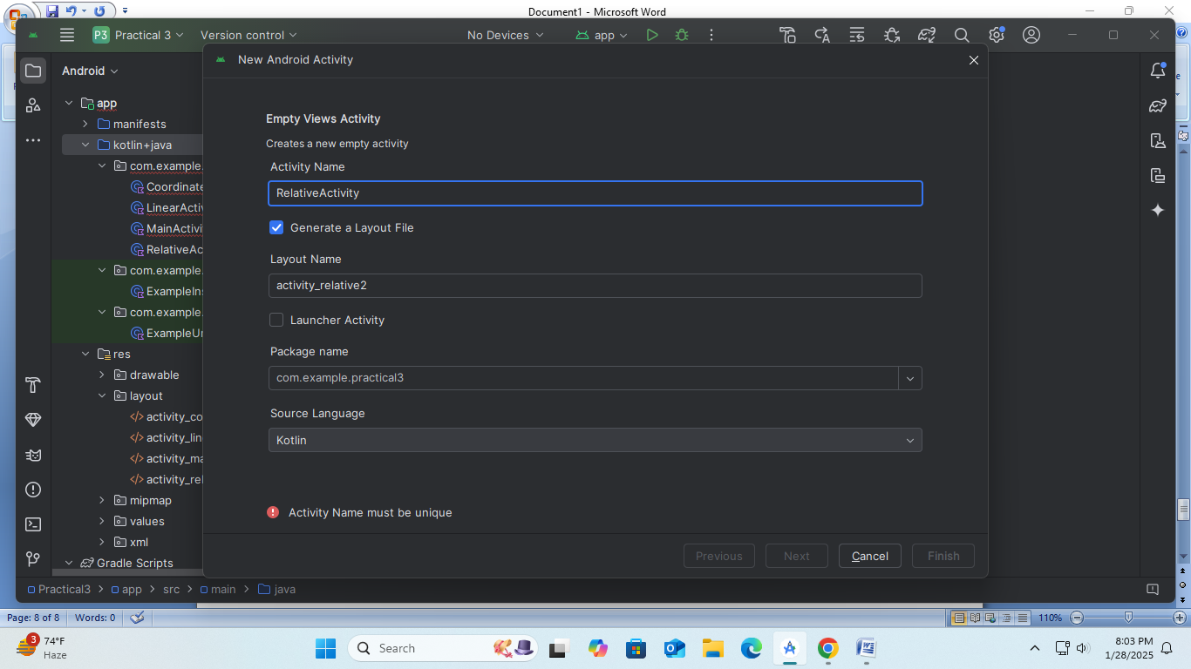

package com.example.layoutexamples

import android.os.Bundle

import androidx.appcompat.app.AppCompatActivity

class RelativeActivity : AppCompatActivity() {

    override fun onCreate(savedInstanceState: Bundle?) {

        super.onCreate(savedInstanceState)

        setContentView(R.layout.activity_relative)

    }

}

**Step 9:** activity_relative.xml

<RelativeLayout xmlns:android="http://schemas.android.com/apk/res/android"

    android:layout_width="match_parent"

    android:layout_height="match_parent">

    <TextView

        android:id="@+id/textView"

        android:layout_width="wrap_content"

        android:layout_height="wrap_content"

        android:text="This is a TextView" />

    <Button

        android:layout_width="wrap_content"

        android:layout_height="wrap_content"

        android:layout_below="@id/textView"

        android:text="Click Me" />

</RelativeLayout>

**Step 10:** Create a new activity – TableActivity.kt

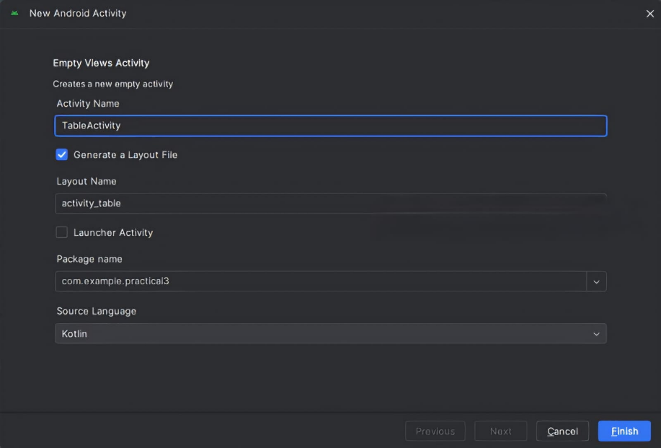

package com.example.layoutexamples

import android.os.Bundle

import androidx.appcompat.app.AppCompatActivity

class TableActivity : AppCompatActivity() {

    override fun onCreate(savedInstanceState: Bundle?) {

        super.onCreate(savedInstanceState)

        setContentView(R.layout.activity_table)

    }

}

**Step 11:** activity_table.xml

<TableLayout xmlns:android="http://schemas.android.com/apk/res/android"

    android:layout_width="match_parent"

    android:layout_height="match_parent"

    android:stretchColumns="1">

    <TableRow>

        <TextView

            android:layout_width="wrap_content"

            android:layout_height="wrap_content"

            android:text="Row 1, Col 1" />

        <TextView

            android:layout_width="wrap_content"

            android:layout_height="wrap_content"

            android:text="Row 1, Col 2" />

    </TableRow>

    <TableRow>

        <TextView

            android:layout_width="wrap_content"

            android:layout_height="wrap_content"

            android:text="Row 2, Col 1" />

        <Button

            android:layout_width="wrap_content"

            android:layout_height="wrap_content"

            android:text="Row 2, Col 2 Button" />

    </TableRow>

</TableLayout>

**Step 12:** Create a new activity – AbsoluteActivity.kt

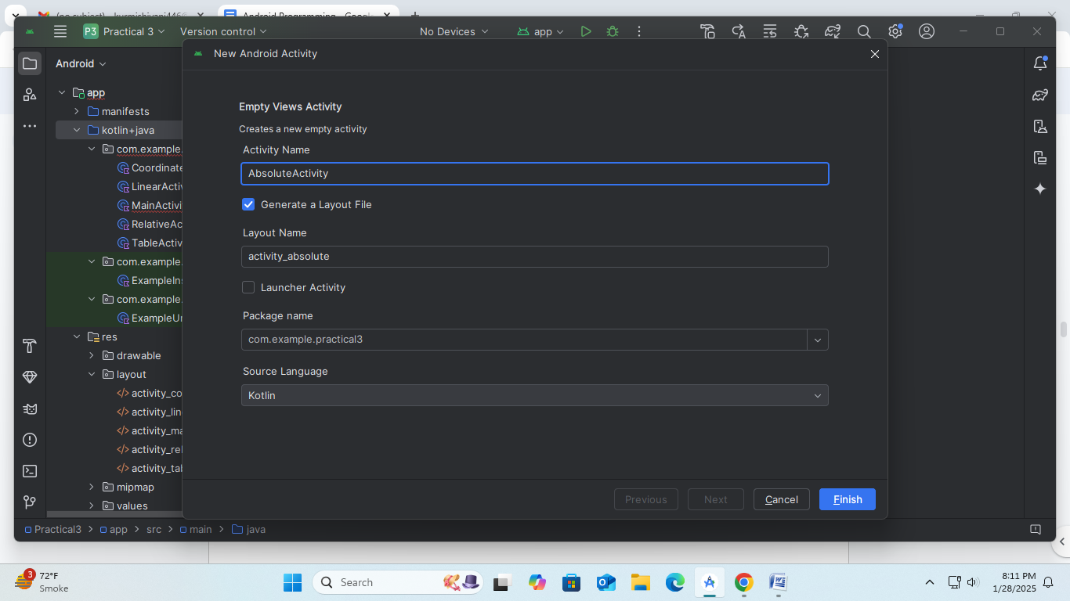

package com.example.layoutexamples

import android.os.Bundle

import androidx.appcompat.app.AppCompatActivity

class AbsoluteActivity : AppCompatActivity() {

    override fun onCreate(savedInstanceState: Bundle?) {

        super.onCreate(savedInstanceState)

        setContentView(R.layout.activity_absolute)

    }

}

**Step 13:** activity_absolute.xml

<AbsoluteLayout xmlns:android="http://schemas.android.com/apk/res/android"

    android:layout_width="match_parent"

    android:layout_height="match_parent">

    <TextView

        android:layout_width="wrap_content"

        android:layout_height="wrap_content"

        android:layout_x="50dp"

        android:layout_y="50dp"

        android:text="TextView at (50, 50)" />

    <Button

        android:layout_width="wrap_content"

        android:layout_height="wrap_content"

        android:layout_x="150dp"

        android:layout_y="100dp"

        android:text="Button at (150, 100)" />

</AbsoluteLayout>

**Step 14:** Create a new activity – FrameActivity.kt

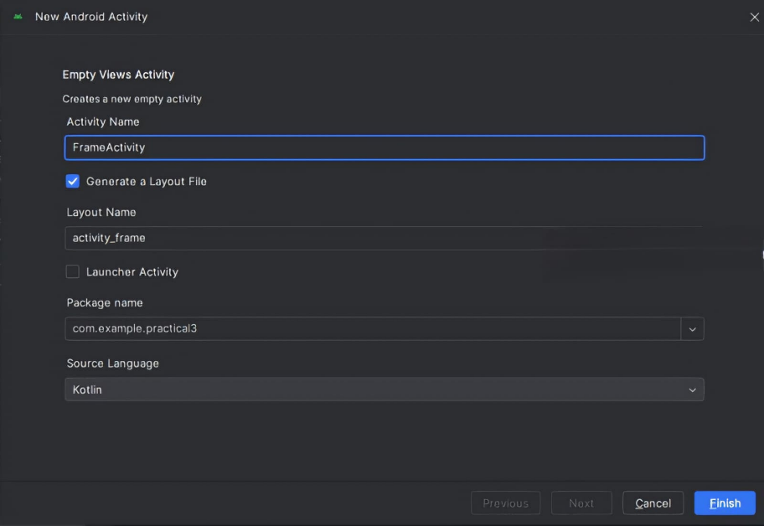

package com.example.layoutexamples

import android.os.Bundle

import androidx.appcompat.app.AppCompatActivity

class FrameActivity : AppCompatActivity() {

    override fun onCreate(savedInstanceState: Bundle?) {

        super.onCreate(savedInstanceState)

        setContentView(R.layout.activity_frame)

    }

}

**Step 15:** activity_frame.xml

<FrameLayout xmlns:android="http://schemas.android.com/apk/res/android"

    android:layout_width="match_parent"

    android:layout_height="match_parent">

    <ImageView

        android:layout_width="match_parent"

        android:layout_height="match_parent"

        android:src="@android:drawable/ic_menu_gallery"

        android:scaleType="centerCrop" />

    <TextView

        android:layout_width="wrap_content"

        android:layout_height="wrap_content"

        android:text="Overlay Text"

        android:layout_gravity="center"

        android:textColor="@android:color/white"

        android:textSize="24sp" />

</FrameLayout>

**Step 16:** Create a new activity – ListViewActivity.kt

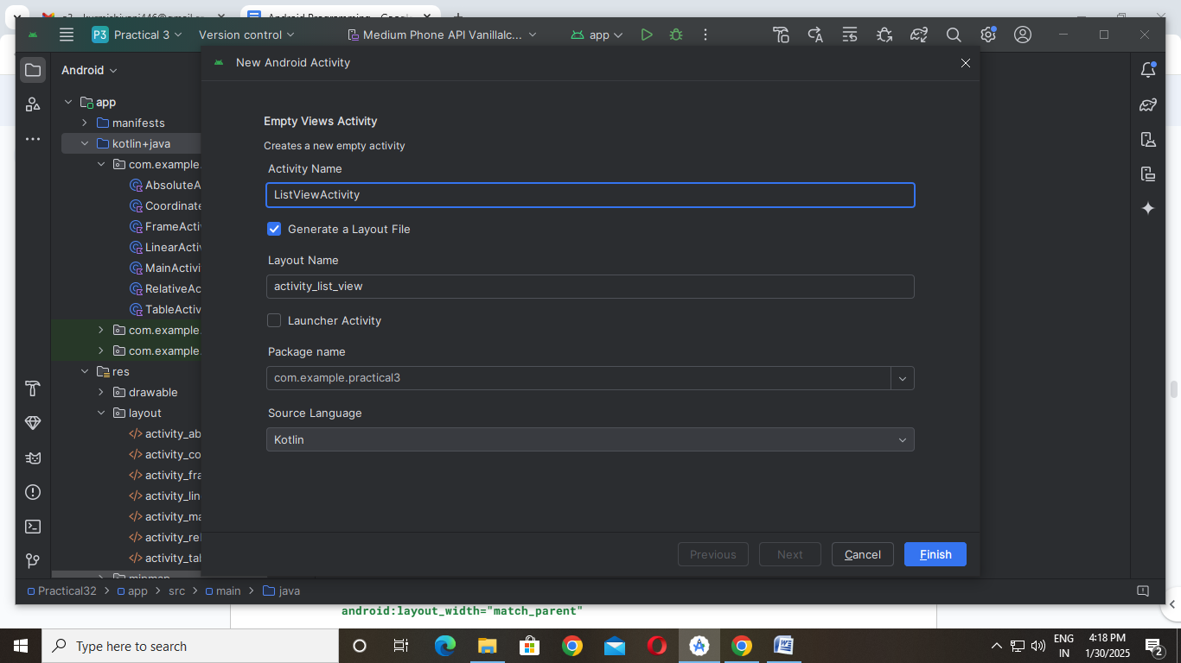

package com.example.layoutexamples

import android.os.Bundle

import android.widget.ArrayAdapter

import android.widget.ListView

import androidx.appcompat.app.AppCompatActivity

class ListViewActivity : AppCompatActivity() {

    override fun onCreate(savedInstanceState: Bundle?) {

        super.onCreate(savedInstanceState)

        setContentView(R.layout.activity_list_view)

        val listView: ListView = findViewById(R.id.listView)

        val data = listOf("Item 1", "Item 2", "Item 3", "Item 4")

        val adapter = ArrayAdapter(this, android.R.layout.simple_list_item_1, data)

        listView.adapter = adapter

    }

}

**Step 17:** activity_list_view.xml

<ListView xmlns:android="http://schemas.android.com/apk/res/android"

    android:id="@+id/listView"

    android:layout_width="match_parent"

    android:layout_height="match_parent" />

**Step 18:** Create a new activity – GridViewActivity.kt

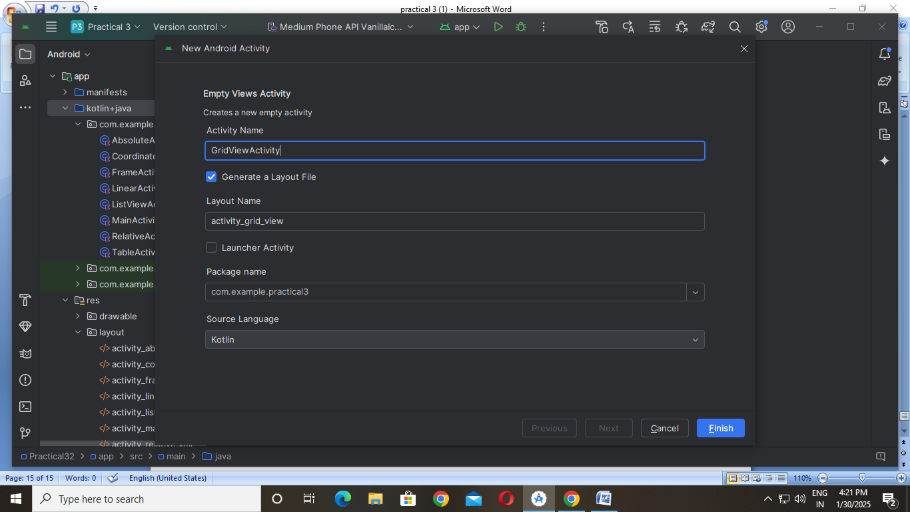

package com.example.layoutexamples

import android.os.Bundle

import android.widget.ArrayAdapter

import android.widget.GridView

import androidx.appcompat.app.AppCompatActivity

class GridViewActivity : AppCompatActivity() {

    override fun onCreate(savedInstanceState: Bundle?) {

        super.onCreate(savedInstanceState)

        setContentView(R.layout.activity_grid_view)

        val gridView: GridView = findViewById(R.id.gridView)

        val data = listOf("A", "B", "C", "D", "E", "F", "G", "H")

        val adapter = ArrayAdapter(this, android.R.layout.simple_list_item_1, data)

        gridView.adapter = adapter

    }

}

**Step 19:** activity_grid_view.xml

<GridView xmlns:android="http://schemas.android.com/apk/res/android"

    android:id="@+id/gridView"

    android:layout_width="match_parent"

    android:layout_height="match_parent"

    android:numColumns="2"

    android:horizontalSpacing="10dp"

    android:verticalSpacing="10dp"

    android:stretchMode="columnWidth" />

**Step 20:** Run the App.

